  
  
  
  
CS 319 - Object-Oriented Software Engineering  
Final Report  
  
  
Project Name: Survivor

Group 2-G

Metehan Kaya - 21401258

Mehmet Taha Çetin - 21400281

Ferhat Karaca - 21400921

Emre Yiğit Kuzhan – 21502056

Table of Contents

1. Changes in the Implementation 3

1.1. Change in User Interface 3

2. Status of the Project 3

3. User’s Guide 4

3.1. System Requirements 4

3.2. Installation 4

3.3. Overview of the Game 4

3.4. Game Entities Subsystem 5

3.4.1 Game Objects 5

3.4.2 Controls 5

3.4.3 Game Screenshots 5

# **Changes in the Implementation**

### **Change in User Interface**

We intend to create C panel class in the design report. In the C panel class, we show credits high score and help options. Instead of show all these options in the C panel class we implemented separate classes for the each options. So, we created three classes in order to show the main menu options which are help, credits and high scores of the Survivor game

# **Status of the Project**

We have successfully created the object of player. Player object can move left, right, up and down with acceleration. Also we created simple obstacles. Player should not crush these obstacles in order to stay alive. However we couldn’t handle the collisions yet. There are 4 environments which are space, ocean, earth, and atmosphere in the Survivor game. We completed one of these environments which is space partially. Player object moves according to the conditions of the space environment. Also, we created main menu of the survivor game. There are 4 option in the main menu. We completed all of these options which are credits, helps, high scores and environments (play game). Other thing that we handle is the scoreboard of the game. We will keep the score of player in the space environment using this scoreboard

# **3. User’s Guide**



## **System Requirements**

Survivor is a Java based game. Therefore, Java run environment should be installed to the computer in order to play the game

**Minimum System Requirements:**

- Windows XP

- Pentium2 233 MHz CPU or higher.

- 256 MB of RAM or higher

- Screen resolution: 1080x1920

**Recommended System Requirements:**

- Windows 10

- Intel i5 2 GHz CPU or higher

- 1 GB of RAM or higher.

- Screen Resolution: 1080x1920

## **Installation**

Right now, the only way that play the Survivor is compiling and running the code that we wrote with Java IDE

## **Overview of the Game**

If player chooses the play option from the main menu, the game starts. There is a space map for now. In the space map, there is a player icon and several objects. Player should not crash these obstacles according to the rules of game. However, we couldn’t handle collision yet. Therefore, collision part of the game is not working for now. Player can move around the map using with the directions buttons of the keyboard. Also player object moves with acceleration according to the frequency of input that read from the user.

## **Game Entities Subsystem**

## **Game Objects**

**Player:** The main object of the game. User controls this object using through the directions buttons of the keyboard.

**Obstacles:** Different type of obstacles will be created in our project. However, there is one type of obstacles right now.

## **Controls**

Up button: move north

Down button: move south

Right button: move east

Left button: move west

## **Game Screenshots**

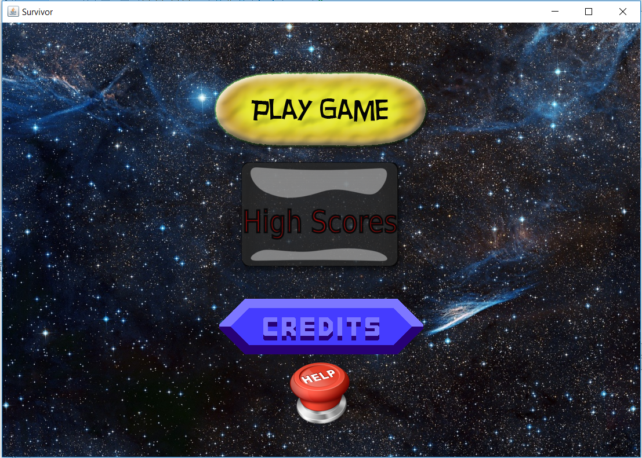

**Main Menu:** When user runs the game, this menu will appear. In this menu the user can choose play game, view help, view credits, and exit game.

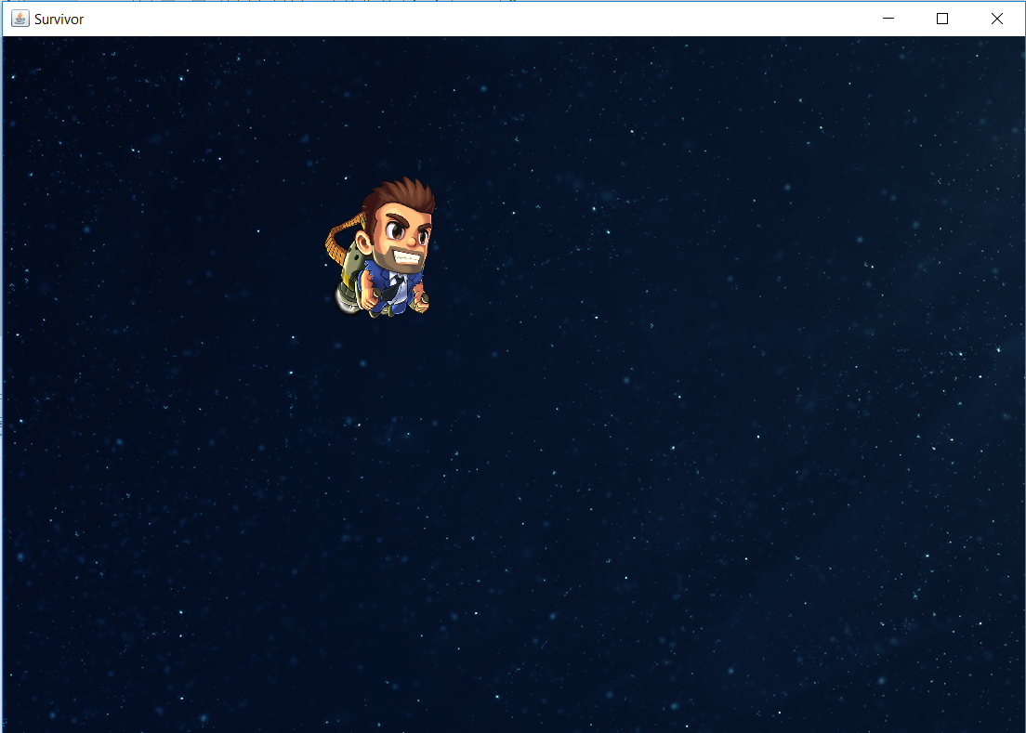

**Play Game:**  When player choose this option, game starts.

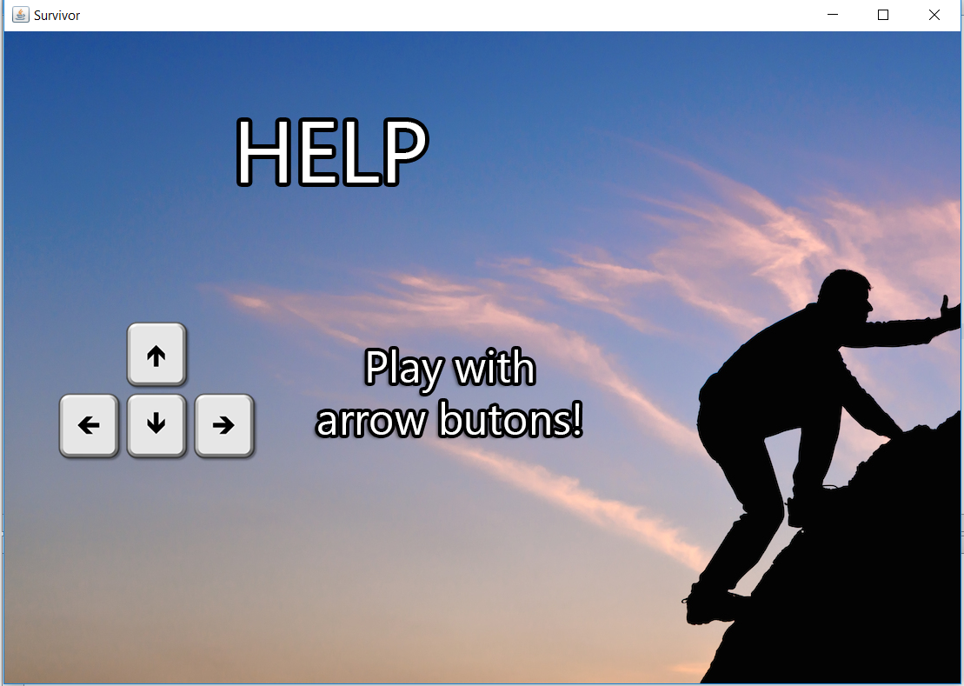

**View Help:** If the user chooses help, some useful contents about the game and instructions are shown

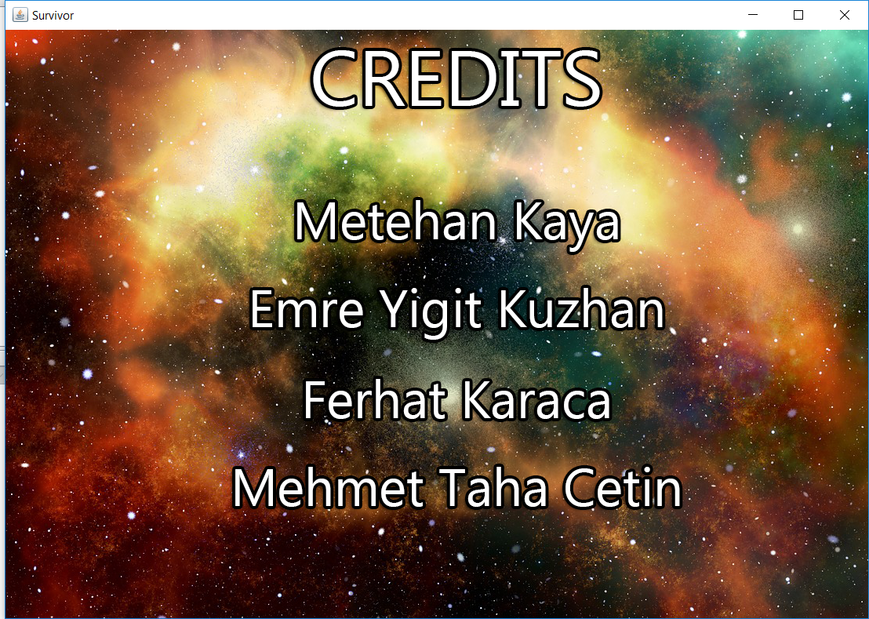

**View Credits:** If the player selects “Credits” button, names of project developers will be shown.

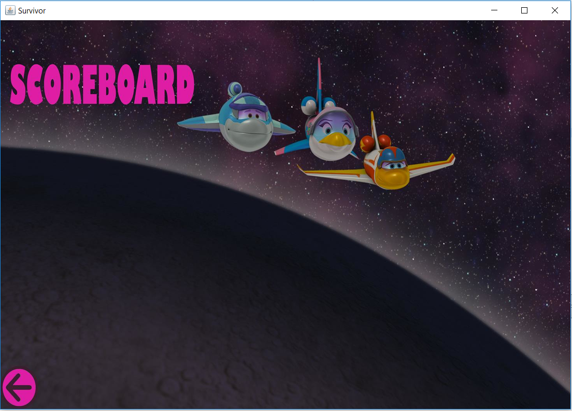

**High Scores:** View High Scores: When “High Scores” button is pressed, game will show the user scoreboard which contains top 10 scores with player names. Initially, the scoreboard has 10 player names and some smooth numbers as scores.